***Challenge 20***

**Goal:**

The goal of this challenge is to use Google and use stack overflow and use all the resources you have on the internet to figure out how you can change the code so that our home page now truncates the content of each blog posts to only 100 characters and then at the end there’s just three dot dot dots.

**truncate string javascript**

<https://stackoverflow.com/questions/1301512/truncate-a-string-straight-javascript>

<https://www.w3schools.com/jsref/jsref_substring.asp>

Use the [substring](http://www.w3schools.com/jsref/jsref_substring.asp) method:

var length = 3;

var myString = "ABCDEFG";

var myTruncatedString = myString.substring(0,length);

// The value of myTruncatedString is "ABC"

So in your case:

var length = 3; // set to the number of characters you want to keep

var pathname = document.referrer;

var trimmedPathname = pathname.substring(0, Math.min(length,pathname.length));

document.getElementById("foo").innerHTML =

"<a href='" + pathname +"'>" + trimmedPathname + "</a>"

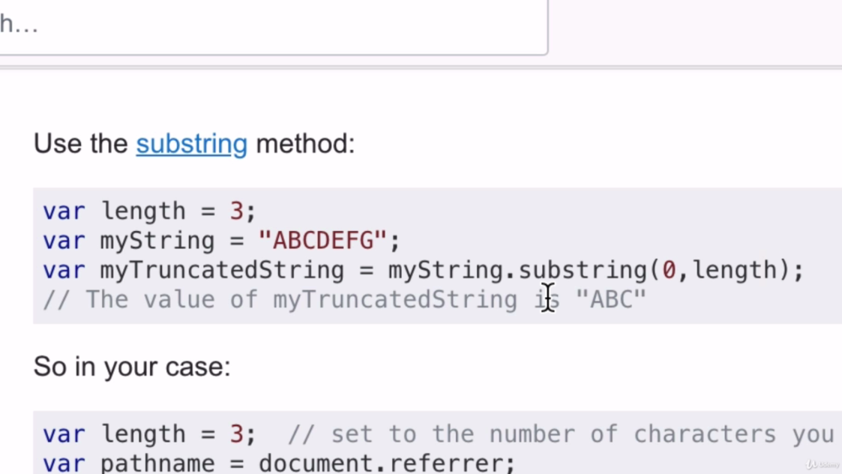

**Solution:**

<p><%= post.content.substring(0,100) +"..." %></p>

**Complete home.ejs:**

<%- include('partials/header'); -%>

<h1>Home</h1>

<p><%= startingContent %></p>

<% console.log(posts); %>

<% posts.forEach(function(post){ %>

<!-- <% console.log(posts.title); %> -->

<h1><%= post.title %></h1>

<p><%= post.content.substring(0,100) +"..." %></p>

<% }); %>

<%- include("partials/footer"); -%>